PRACTICAL NO.9

Sum of Series of Hexadecimal of 8-bit

OUTPUT:

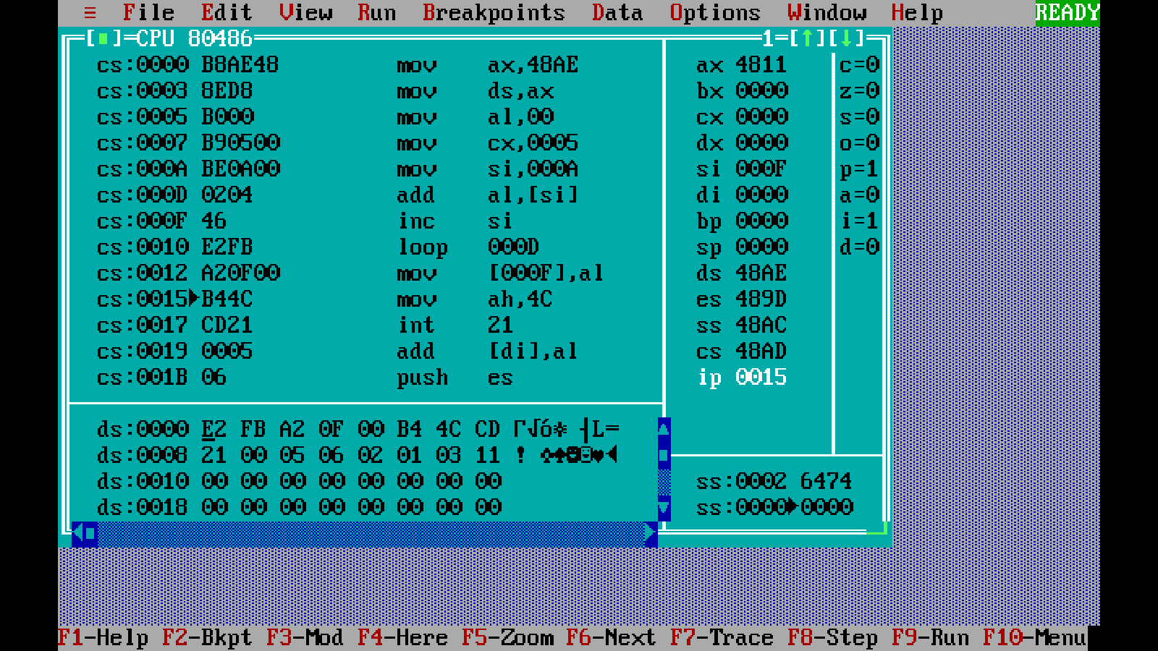

Sum of Series of Hexadecimal of 16-bit

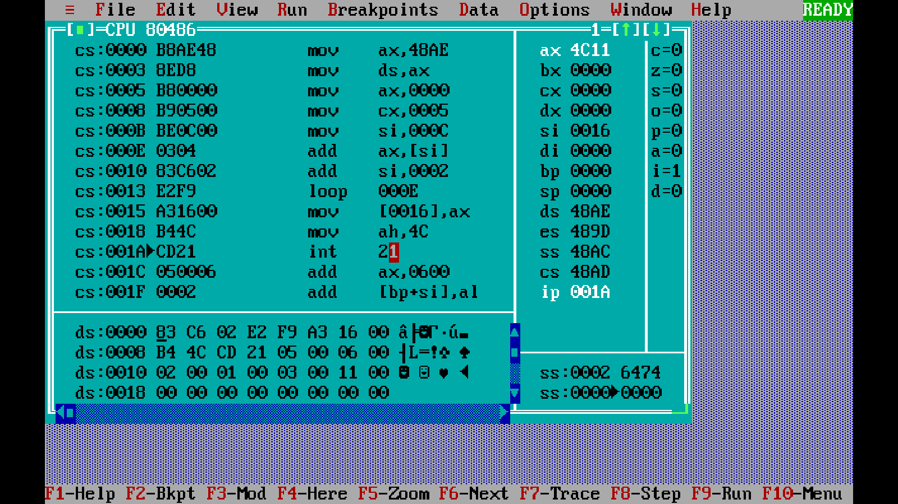

Sum of Series of decimal of 8-bit

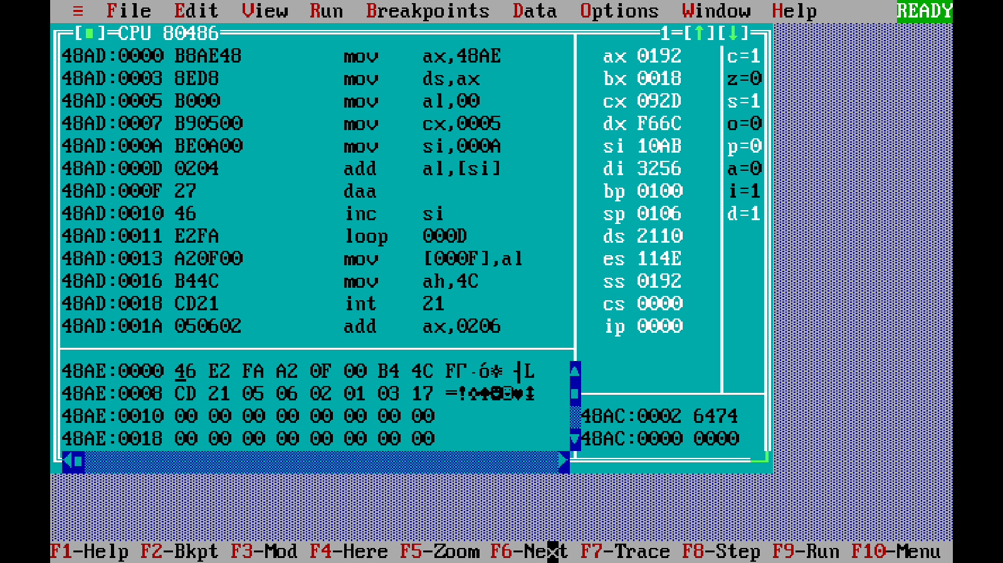

Sum of Series of decimal of 16-bit

